**INTERNATIONAL UNIVERSITY**

**SCHOOL OF ELECTRICAL ENGINEERING (EE)**

**EE091**

**ELECTRONIC DEVICES**

**LAB 4**

**COMMON EMITTER**

**AMPLIFIER - NPN**

**Full name:………………………………..**

**Nguyễn Minh Đức - ITITIU21045………………………...**

**Nguyễn Quang Tâm - ITITIU21304………………………..**

**Tôn Long Thuận - ITITIU21322………………………...**

**Electronic devices** Page 1 of 5

**INTERNATIONAL UNIVERSITY**

**SCHOOL OF ELECTRICAL ENGINEERING (EE)**

1. **OBJECTIVES**

This lab introduces the operation of common emitter amplifier. You will know how to build a CE circuit, measure the gain and compare to the theory calculation

1. **MATERIAL AND EQUIPMENT**
   * 1. Oscilloscope
     2. Power Supply
     3. Multimeter
     4. 2N3904
     5. Assorted Resistors
   1. **SIMULATION**

For simulation activity, you are responsible for performing **BOTH** the **calculation** of figure 1 circuitry for NPN transistor 2N3904 as well as **simulations** for all scenarios. **you must perform your simulation of circuitries**. The performance of PRELAB thistime in advanced is recommended, as the lab procedure will be quite difficult and take time. Assuming = 100, = 0.7 .

**IV. PROCEDURE**

In this section, you will analyze a common emitter amplifier, a popular transistor amplifier circuit.

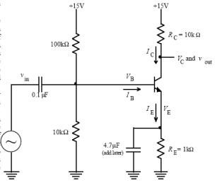

Figure 1: Common emitter amplifier.

**Electronic devices** Page 2 of 5

**INTERNATIONAL UNIVERSITY**

**SCHOOL OF ELECTRICAL ENGINEERING (EE)**

**4.1. DC analysis**:

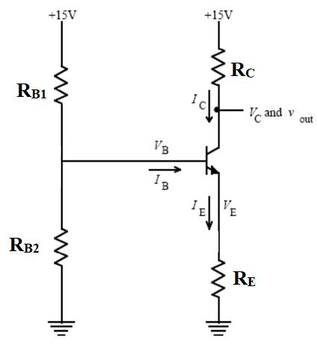

Figure 2: Common emitter amplifier – DC Analysis.

Using a digital multimeter to measure DC values of voltage 𝑉𝐶𝐸, 𝑉𝐶, 𝑉𝐸, 𝑉𝐵𝐸, 𝑉𝐵𝐶, 𝑉𝐵 then calculate current values 𝐼𝐵, 𝐼𝐶, 𝐼𝐸.

|  |  |  |  |  |  |  |  |  |  |  |
| --- | --- | --- | --- | --- | --- | --- | --- | --- | --- | --- |
|  | 𝑉𝐵 | 𝑉𝐸 | 𝑉𝐶 | 𝑉𝐵𝐸 | 𝑉𝐶𝐸 | 𝑉𝐵𝐶 | 𝐼𝐵 | 𝐼𝐸 | 𝐼𝐶 | β |
| **Calculation** | 1.33 | 0.58 | 8.2 | 0.75 | 7.62 | -6.87 | 4.75 x10-6 | 682 x10-6 | 675.5 x10-6 | 100 |
| **Simulation** | 1.32 | 0.667 | 8.38 | 0.653 | 7.713 | -7.06 | 4.86 x10-6 | 667 x10-6 | 662 x10-6 | 158 |
| **Measurenent** | 1.29 | 0.68 | 8.4 | 0.72 | 7.55 | -6.86 | 4.85 x10-6 | 734 x10-6 | 715.5 x10-6 | 270 |

**4.2. AC analysis**:

1. Connect the function generator to and use a 1V peak-to-peak 1kHz sine wave as the input signal, with the coupling capacitor 1 = 0.1. Monitor and simultaneously with the oscilloscope and sketch them on the same set of axes.

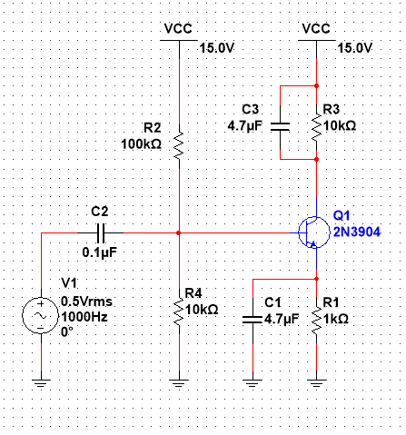

1. Measure the gain of this amplifier. Compare it to the calculated gain, 𝑅𝐶⁄𝑅𝐸 . Note the phase difference from input to output.

**Vout = 15.6, Vin = 1.03, k = 15.14563 > 𝑅𝐶⁄𝑅𝐸**

1. The output of an ideal amplifier should always look just like the input multiplied by the gain. However, real amplifiers only work correctly over a limited range of output voltages and frequencies. Explore the behavior of the amplifier a little more by performing the following steps:

* Using different waveforms (Sine wave, Square wave and Triangle wave). For each input waveform, try adjusting and simultaneously with the oscilloscope and sketch

**Electronic devices** Page 3 of 5

**INTERNATIONAL UNIVERSITY**

**SCHOOL OF ELECTRICAL ENGINEERING (EE)**

them on the same set of axes. Also, report on their respective gain on each case. Is the phase difference from input to output the same when we change the input waveform?

|  |  |  |  |
| --- | --- | --- | --- |
| **Waveforms** | Sine wave | Square wave | Triangle wave |
| **Gain (simulation)**  (f = 1kHz) | Vout = 5.03  Vin = 0.68V  Av = 8.1 | Vout = 5.45V  Vin = 0.82V  Av = 8.3 | Vout = 4.1V  Vin = 0.39V  Av 8.51 |
| **Gain**  **(measurement)**  (f = 1kHz) | Vout = 4.5  Vin = 0.71V  Av = 7.44 | Vout = 5.51V  Vin = 0.73V  Av = 8.11 | Vout = 4.715V  Vin = 0.47V  Av 8.3 |

Using different amplitudes for , report the gain of each case’jn according to the following table:

|  |  |  |  |  |  |
| --- | --- | --- | --- | --- | --- |
| , _ | Gain | Gain | , _ | Gain | Gain |
|  | (Simulation) | (Measurement) |  | (Simulation) | (Measurement) |
|  |  |  |  |  |  |
| 1 | 1.34/0.71=1.88 | 26 | 8 | 1.79/5.66=0.32 | 3.9796 |
|  |  |  |  |  |  |
| 2 | 1.42/1.41=1 | 15.1563 | 10 | 2.46/7.06=0.35 | 3.1452 |
|  |  |  |  |  |  |
| 4 | 1.54/2.83=0.54 | 7.9592 | 12 | 2.04/8.49=0.24 | 2.6351 |
|  |  |  |  |  |  |
| 6 | 1.66/4.24=0.39 | 5.2702 | 14 | 2.16/9.9=0.22 | 2.2941 |
|  |  |  |  |  |  |

Return theback to the original value. Now, try using different load resistor values , and report the gain of each cases according to the following table .

|  |  |  |  |  |  |
| --- | --- | --- | --- | --- | --- |
| 𝑅𝐶 | Gain (Simulation) | Gain (Measurement) | 𝑅𝐶 | Gain (Simulation) | Gain (Measurement) |
| 1𝑘Ω | 30.55 | 30.41667 | 5.6𝑘Ω | 28.33 | 28.125 |
| 2.2𝑘Ω | 31.92 | 30.2083 | 6.8𝑘Ω | 26.92 | 27.5 |
| 3.3𝑘Ω | 28.85 | 29.375 | 10𝑘Ω | 26.95 | 25.83 |
| 4.7𝑘Ω | 27.55 | 28.75 | 22𝑘Ω | 30.22 | 29.583 |

* Return the and back to the original value. Now, try using different frequency values, and report the gain of each cases according to the following table. Given that the formula to calculate the gain is:

**Electronic devices** Page 4 of 5

𝑉𝑜𝑢𝑡

𝐺𝑎𝑖𝑛 (𝑑𝐵) = 20𝑙𝑜𝑔 ()

𝑉𝑖𝑛

|  |  |  |  |  |  |  |  |
| --- | --- | --- | --- | --- | --- | --- | --- |
| Frequency | Gain | Frequency | Gain | Frequency | Gain | Frequency | Gain |
| 100 | 26.96 | 1000 | 19.45 | 10,000 | 28.72 | 60,000 | 18.68 |
| 200 | 27.58 | 2000 | 19.45 | 20,000 | 28.72 | 70,000 | 18.68 |
| 400 | 27.95 | 3000 | 19.45 | 30,000 | 28.72 | 80,000 | 18.68 |
| 600 | 28.03 | 4000 | 19.45 | 40,000 | 18.68 | 90,000 | 28.03 |
| 800 | 28.72 | 5000 | 19.45 | 50,000 | 18.68 | 100,000 | 28.03 |

Now, add the Bypass capacitor 𝐶2 = 4.7𝜇𝐹 in parallel with the resistor 𝑅𝐸. See how the gain changes when you add this capacitor. Can you explain this? Repeat the process of changing the input frequency from 100Hz to 100KHz like above. Determine the gain *dB* and plot the frequency response. Determine approximately the minimum and

*out*

*in*

*v*

*v*



maximum frequencies for which the gain is constant. Try to guess what causes these limits.

|  |  |  |  |  |  |  |  |
| --- | --- | --- | --- | --- | --- | --- | --- |
| Frequency | Gain | Frequency | Gain | Frequency | Gain | Frequency | Gain |
|  |  |  |  |  |  |  |  |
| 100 | 30.67 | 1000 | 30.67 | 10000 | 30.67 | 60000 | 30.67 |
|  |  |  |  |  |  |  |  |
| 200 | 30.67 | 2000 | 30.67 | 20000 | 30.67 | 70000 | 30.67 |
|  |  |  |  |  |  |  |  |
| 400 | 30.67 | 3000 | 30.67 | 40000 | 30.67 | 80000 | 30.67 |
|  |  |  |  |  |  |  |  |
| 600 | 30.67 | 4000 | 30.67 | 40000 | 30.67 | 90000 | 30.67 |
|  |  |  |  |  |  |  |  |
| 800 | 30.67 | 5000 | 30.67 | 50000 | 30.67 | 100000 | 30.67 |
|  |  |  |  |  |  |  |  |

1. Finally, add the Coupling capacitor 3 = 4.7 connected to the Collector terminal. See how the output signal change when you add this capacitor. Can you explain this? Capture the output signal for your report.

To prevent potential damage to the load resistor caused by the DC bias voltage at the collector, a coupling capacitor is employed. This capacitor effectively inhibits the transmission of the DC voltage to the output of the amplifier, serving as a protective measure.

The coupling capacitor also plays a role in diminishing the high-frequency gain by functioning as a high-pass filter. This implies that it permits the passage of high-frequency signals while obstructing low-frequency signals. The cutoff frequency of this filter is dictated by the capacitor's value and the load resistor's value, with a larger capacitor resulting in a lower cutoff frequency and a smaller capacitor yielding a higher cutoff frequency.

**Electronic devices** Page 5 of 5